# find Assignment

**Mandatory:**

1. Search and display all *.c and *.h files in all subdirectories starting from current directory

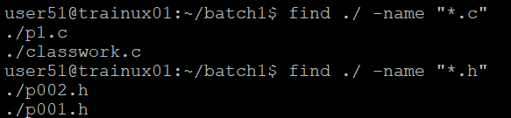

1. Search and display all directories in all subdirectories starting from current directory

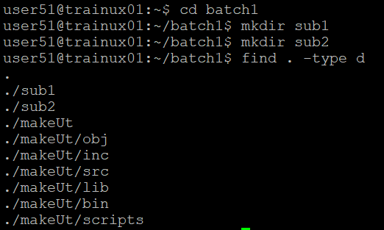

1. Search and display all files with permissions only rw with user and execute permission for others

Ans: find . -type f -perm 0601

find . -type f -perm -u=rw -perm -o=x

find . -type f -perm -u=rw,o=x

**Optional Assignments:**

1. Search and copy all files whose size is < 500 bytes to a directory named “backup”
2. Starting from home directory , find and display all
   * 1. empty files
     2. readonly files
     3. all empty directories
3. Search for a user input pattern in a set of files, extract all lines with the pattern , redirect to a file and display the contents of the file
4. Search and display all files which were modified in last 15 days
5. Search and display all file which were modified in last 10-15 days
6. count the number of words in all *.txt files in a directory and display
7. In a given directory sort all files based on their size (descending order) and then read and display the contents of each file